**CEO recruitment –** The Board have engaged [The Lucas Group | Agribusiness Executive Search & Recruitment](https://lucasgroup.com.au/) to lead the executive search for our new CEO. Further information is available on our website [here](https://lucasgroup.com.au/wp-content/plugins/bullhorn-oscp/#/jobs/3795), with the initial applications due by Friday 28 April.

**CICL Careers –** We have updated the  [Careers](https://www.colyirr.com.au/careers) section of our website including making a supporting video which features some staff talking about our workplace. Attracting and retaining quality staff is an issue facing most employers and the aim of our recent improvements to our website is to promote our workplace and what CICL has to offer, including diverse employment opportunities.

Thank you to our staff and farmers who assisted with the video production.

**Water Operations planned end of season –** CICL plans to close its river offtake on Monday 22 May 2023 to allow winter maintenance to commence.

After the river offtake closes, supply is no longer guaranteed, however, delivery of orders will continue subject to water availability at a customer’s outlet.

Draining of supply channels will start early June or as demand ceases.

You are reminded to contact Water Operations to discuss your end of season water orders or provide an update if your plans have changed.

Customers should **place water orders for their end of season irrigation needs as soon as possible but before the planned offtake closure on Monday 22 May 2023.**

After the offtake closes preference will be given to orders placed prior to the closure.

The contact for Water Operations – Business Hours T: 02 6954 4003 – After Hours M: 0427 544 269.

**NSW Department of Planning & Environment Allocation announcements**

**16/1/23**

High Security 100%

General Security 100%

Groundwater 100%  
(*Lower Murrumbidgee)*

**CICL announcement and offer**

Member benefit 10%

Additional water offer 4%

**Waterways**

<http://www.colyirr.com.au>

T: 1300 850 105

**End of season key dates:**

**WaterNSW deadline, Murrumbidgee Regulated River interstate trade –** 11.59pm Sunday 30 April 2023.

***WaterMart***



The WaterMart platform can be accessed [here](https://www.colyirr.com.au/watermart/).

WaterMart will close at **4pm on** **Wednesday 31 May 2023.**

The Platform will commence trade for the 2023/24 water season on Monday 3 July 2023.

***Annual transfers to and from CICL’s licence close -* 4pm Wednesday 31 May 2023.**

***Annual transfers between CICL farms – 12 noon* Friday 9 June 2023.**

***Single Farming Unit Accounting Close* – 12 noon Friday 9 June 2023.**

**Inter-valley trade (IVT)**

Up-to-date information on the IVT is [here](https://www.waternsw.com.au/customer-service/ordering-trading-and-pricing/trading/murrumbidgee).

**You can register for WaterNSW IVT alerts** [**here**](https://www.waternsw.com.au/customer-service/news/subscribe)**.**

**Water use intensity 2023/24 -** Members are advised that total farm water use (including on-farm bores) should not exceed **8ML/ha** for the 2023/24 water season unless they have entered into a Water Use Averaging Agreement with CICL.

These agreements allow for averaging water use between unconnected farms and exempting farms from water use limits for approved primary industries. Members must make an application in writing to CICL for a Water Use Averaging Agreement and the Agreement must be finalised before the mid-December allocation announcement for the Agreement to apply for the current season. Please contact Keith Thompson via reception on T: 02 6954 4003 for further information.

**Updated CICL Water Use Policy –** CICL has updated its Water Use Intensity Policy. The revised policy will apply from 1 July 2023 and can be accessed [here](https://static1.squarespace.com/static/5af3b1ae70e8023a6ac7a10b/t/6448702ca423de406895f78f/1682468909406/CIA+Water+Use+Policy+from+1July2023.pdf).

**Carryover into 2023/24 water season –** The carryover provisions in the Water Sharing Plan for the Murrumbidgee Regulated Water Source apply to CICL water entitlements. This means that:

* A volume of up to 30 percent of general security water entitlements can be carried over from 2022/23 to 2023/24.
* Carryover is not available on high security or G class water entitlements.
* The maximum account limit on general security water entitlements in 2023/24 including carryover and the announced allocation is 100 percent.

Members with more than 30 percent available in their general security water allocation account, or water remaining in their high security water allocation account, should note the closing date for WaterMart and annual transfers to and from CICL’s licence of **4.00pm Wednesday 31 May 2023.**

**For internal annual trades and Single Farming Units the closing date is 12 noon Friday 9 June 2023.**

**Stock and Garden Meter Readings -** Over the next few weeks, Water Operations will be undertaking the yearly run of stock and garden meter readings. Please be mindful that CICL staff could be on farm undertaking these readings.

**Water availability outlook for 2023/24 –** The Department of Planning and Environment released an outlook update on Monday 17 April, this can be found [here](https://www.industry.nsw.gov.au/water/allocations-availability/allocations/statements/_nocache?utm_source=Water+Availability+Updates&utm_campaign=7446f700e9-EMAIL_CAMPAIGN_2018_11_14_05_47_COPY_01&utm_medium=email&utm_term=0_c09f71d9dd-7446f700e9-93547689).

Key points to note:

* General security carryover from this year to 2023/24 is expected to be 30 percent of general security water entitlements.
* Starting allocations for high security allocation on 1 July of 95 percent.
* Starting conveyance allocations in accordance with the water sharing plan rules.
* Starting allocations for general security is expected to be 15 percent.

This information is only an estimate based on current inflows with a recession to the extreme dry (i.e. conservative). The starting announcement assumes there is some forfeit of water remaining in accounts on 30 June 2023.

Any undelivered IVT account water (likely to be close to 100GL) remains in Murrumbidgee storages and is callable as a NSW Murray resource.

**Report suspicious activity around CICL infrastructure -** In recent weeks we have had infrastructure stolen and damaged, mainly access gates on our irrigation channels. CICL thanks members who have contacted us to report these incidents. If you notice suspicious activity around our infrastructure, please contact Kevin Kelly on M: 0428 544 273 or Paul Muir on M: 0427 544 505.

**CropX Trial -** CICL is looking to improve the understanding of demand scheduling for both our Water Operations staff and members. To do this, a trial with CropX has been approved which includes access to soil moisture probes at a reduced cost. The trial will begin in time for this winter crop and will continue until the end of the 2023/24 summer crop season. If any members would like to participate in this trial, or like any further information on CropX, please email George Payne at [gpayne@colyirr.com.au](mailto:gpayne@colyirr.com.au).

We thank all involved for their contribution toward the development of the Rubicon Water Ordering application. The feedback on functionality and requirements in this trial have been invaluable. Rubicon have experienced some issues with the development and implementation of an app and are now changing their direction toward a web-based platform.

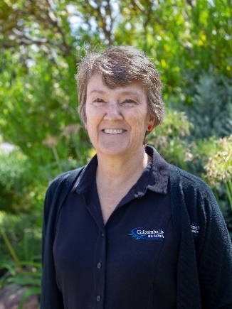**Introducing Alison Hayes - Human Resources and Finance Officer**

**How long have you worked for CICL and what is your role?**  **–** I have worked for CICL for 12 years, initially as a Finance Officer and in the last year as the Human Resources Officer too.

**What were you doing before you joined CICL? –** I was a Teacher’s Aide at St Peter’s Primary School.

**What does your job entail? –** I am responsible for recruiting and managing employee needs and supporting their wellbeing. In my finance role I am responsible for accounts payable and receivable, and maintaining the financial aspects of our asset register.

**What is a common question you get from staff? –** We have a staff morning tea each Friday and I am often asked who is on morning tea this week?

**What is the favourite part of your job? –** Welcoming new staff members. This is when all the hard work of recruiting has paid off. I also enjoy organising wellbeing activities for our staff.

**What do you like to do when you are not working? –** I like to read, practice yoga, and get involved in our community.

**What is your favourite quote –** “One positive thought in the morning can change your entire day.” Dalai Lama

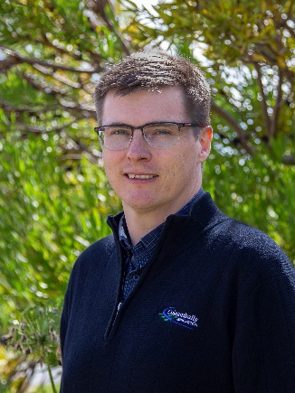**Introducing Michael Wilson Information System Officer**

**How long have you worked for CICL?**

**–** I have worked for CICL for nearly 15 years.

**What were you doing before you commenced with CICL? -** I went to University in Wagga Wagga. I also did some seasonal work for Warburn Estate, Tharbogang, along with some other seasonal work.

**What does your job entail? -** Looking after all things IT including servers, networks, databases, applications and help desk. A little bit of photography and graphic design thrown in every now and then, including for the annual report and annual compliance report.

**What is a common question you get from staff? -** This isn’t working. Can you fix it for me?

**What is the favourite part of your job? –** Getting to work with some “cool” technology and equipment and I enjoy the design work too.

**What do you like to do when you are not working? -** Spending time with family. Catching up on TV shows and movies. Listening to music and anything involving motocross.

**What is something you want to share about yourself? –** My favourite band is BMTH, British Rock Band, Bring Me the Horizon.

**Independent tip tests –** These are a part of CICL’s commitment to the accuracy of its farm meter fleet. A total of 30 tip tests were completed by an independent assessor during the current season. This work complements two rounds of internal tip tests undertaken each year of active farm FlumeGate™ outlets.

**Grant Latta bonded scholarship -**

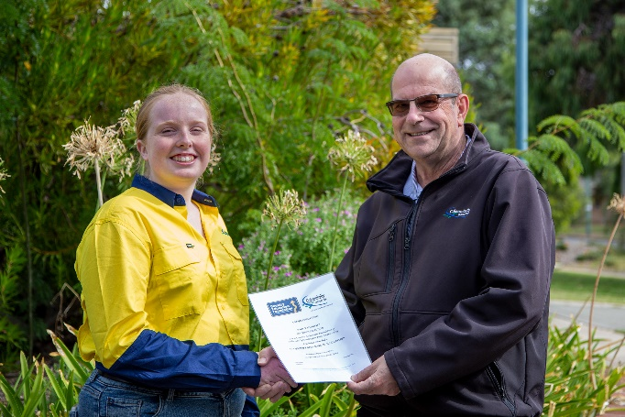 CICL along with the Country Education Foundation is pleased to announce Emily Hibbert as our latest recipient of the Grant Latta Bonded Scholarship.  Emily is from a local farming family and has recently commenced her first year of study in Agricultural Science at Charles Stuart University Wagga campus.  Emily will be working casually in the CICL compliance division while studying. This is a wonderful opportunity for her to gain valuable experience.  Once Emily has graduated, she will work full time for CICL.

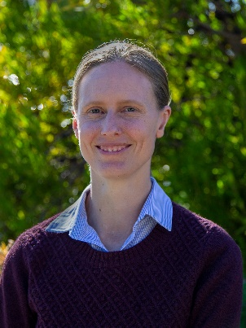**GIS Officer –** CICL is pleased to announce the appointment of Laura Sleeman to the Geographic Information Systems position. Laura has moved to Coleambally from western Victoria. Laura comes to CICL with over 10 years’ experience working on data related projects in a range of GIS applications. She holds a Bachelor of Environmental Science and is doing her Master of Science in Agriculture specialising in the application of GIS technologies.  Laura’s previous employment including interesting work in Kenya using GIS technology for monitoring agricultural practices.  We welcome Laura to Coleambally.

**External issues**

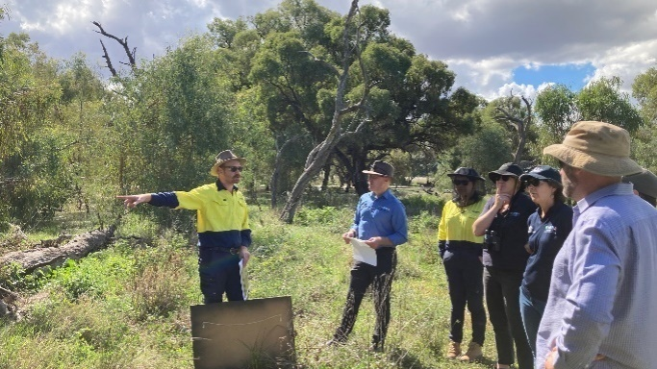

*Commonwealth Environmental Water Holder, Dr Simon Banks, visiting CICL biodiversity reserve, April 2023*

**NSW Labor Government –** The Hon. Rose Jackson is Water Minister. Rose is a member of the NSW Legislative Council (Upper House). Rose was previously shadow Water Minister, which means she is familiar with the key Murray-Darling Basin Plan (Basin Plan) issues.

The consequences of NSW’ failure to complete its Sustainable Diversion Limit Adjustment Mechanism (SDLAM) projects, and the importance of finding alternative projects and allowing more time to complete good projects were communicated to the Minister when she was in opposition.

CICL along with NSWIC and National Irrigators’ Council will highlight to Rose the importance of NSW finding a solution to finishing the Basin Plan that does not take more water from the productive pool.

Other relevant Ministers to CICL are the Hon. Penny Sharpe, Minister for Climate Change and Energy, and Minister for Environment, and the Hon Tara Moriarty, Minister for Agriculture, Minister for Regional NSW, and Minister for Western NSW. All these ministers are members of the Legislative Council.

The government will require the support of some (but not all) of the independents to pass legislation in the Legislative Assembly (Lower House).

Alex Greenwich, Sydney, Dr Joe McGirr, Wagga Wagga, and Greg Piper, Lake Macquarie, guaranteed support to allow Labor to form the government. Since then, the NSW Government has offered to support Greg Piper to be speaker of the Legislative Assembly, with a vote for the speaker when parliament resumes in May. The Government has also said it will continue its good faith approach to dealing with the crossbenchers and independents. There are three Greens in the Legislative Assembly and six independents including Murray, Barwon, Orange, and Wagga Wagga.

In the Legislative Council (Upper House) the government and opposition hold equal numbers and the government will need to gain the support of the crossbenchers to pass legislation.

**Murray-Darling Basin Plan** (the Plan) **–** The legislated deadlines in the Plan are fast approaching. Without agreement from our elected politicians to allow increased flexibility, Basin communities face the real prospect of further water recovery from the consumptive pool in the next two years.

CICL’s key concern is the failure of government to successfully achieve their commitments to projects that provide benefits equal to 605GL of environmental outcomes through the SDLAM projects.

In the Murrumbidgee Valley, the benefit of the SDLAM is 162GL (27 percent of the 605GL). If the shortfall anticipated by the MDBA of between 190GL and 315GL eventuates a share of this will come from the Murrumbidgee Valley.

The likely impact of a 315GL shortfall on the Murrumbidgee is 85GL.

**This is 85GLs of “actual” water. Long term diversion limit extraction (LTDLE) factors are** used to allow the different types of water entitlements to be compared. In the Murrumbidgee, a general security water entitlement has a LTDLE of 0.591. This means 85GL is equal to 144GL of general security water entitlements and approximately 10 percent of the general security water entitlements remaining in the consumptive pool (i.e. excluding water entitlements already owned for environmental purposes).

The Commonwealth can buy back any shortfall up to the legislated 1,500GL cap without changing the legislation.

The most recent figures show nearly 272GL can be purchased under the 1,500GL buyback cap.

**This is why achieving the flexibility to add new projects and extend timeframes to avoid this impact on our region is our number one priority.**

The Commonwealth Government also came to power with an election commitment to recover the 450GL of efficiency measures.

It is CICL’s view the Basin Plan requires 62GL of efficiency measures which work together with the 605GL of SDLAM. This is also the Victorian Labor Government’s view. The balance of the 450GL must be from voluntary efficiency projects that are at least socially and economically neutral.

NSWIC completed an excellent analysis of what recovering an additional 450GL may look like in the southern Basin. This work can be found [here](https://www.nswic.org.au/wp-content/uploads/2022/08/2022-08-01-450-Report-FINAL.pdf).

The findings show that recovery of the additional 450GL represents a sizeable proportion of the remaining water in the consumptive pool in the southern connected systems.

*“Whether the water is recovered through on-farm efficiency programs or buybacks, the reduction in the consumptive pool is the same as both recovery methods involve transferring existing entitlements across to the environment.*

*Recovery of this water will therefore have significant socio-economic and water market impacts.”* NSWIC, July 2022.

These are sobering messages which signal the significant challenges facing the irrigation sector and regional communities. CICL encourages you to support the communication efforts of our peak bodies, particularly their social media campaigns. More information is available [here](https://www.nswic.org.au/media-campaigns/).

Our effort continues to focus on minimising the harmful impacts of water recovery and supporting the development of alternative solutions. We continue to support the efforts of both irrigators councils and the need to have a united voice. Peak groups will be essential when communicating with both the Commonwealth and State Labor Governments who have no electoral representation in the Murray-Darling Basin.

**Metering compliance deadline -** For members with groundwater bores the deadline of 1 June 2023 for compliance with the NSW non-urban metering standard is fast approaching. Bore owners can expect the Natural Resources Access Regulator to follow up on their progress with installing compliant meters. Further information is [here](https://water.dpie.nsw.gov.au/nsw-non-urban-water-metering).

**National Renewables in Agriculture Conference and Expo in Dubbo – Members interested in finding out more about the options for using renewable energy may be interested in this conference. More information and ticket sales are at this link** [Renewables in Agriculture](https://renewablesinagconference.com.au/) **The** guest speaker is Ross Garnaut. The conference is on Wednesday 21 June 2023, and there is a half-day tour on Thursday 22 June.

**Conclusion –** After a lot of deliberation I have chosen to retire from full-time employment when my contract ends in October 2023. I thank the Board for their continuing support and confidence. From my perspective I will continue to work diligently for CICL until my tenure concludes and while the executive search for a new CEO progresses.

The next six month includes the following important activities:

* Finalising CICL’s 2023-2028 Strategic Plan; a summary of our updated Strategy will be available mid-year.
* Preparation of CICL’s annual financial statements and annual report and holding of the 2023 Annual General Meeting.
* Collaborating with our peers in the irrigation industry, our Chair and the Policy and Communication Manager, to minimise the risks which external issues present to CICL and its members.

In raising our concerns with the Plan with you it is not to alarm but highlight what our sector is facing.

This newsletter includes key dates for end of season arrangements. Please note the relevant dates. It is essential anyone looking for supply after the offtake closes on 22 May has placed a water order.

Please also note the two dates for close of annual transfers, with annual transfers to or from our licence (external transfers) closing at 4.00pm on Wednesday 31 May 2023.

To provide flexibility and improved service, the closing date for internal annual transfers and SFU account balances is 12 noon Friday 9 June 2023.

CICL is pleased to welcome Laura Sleeman and Emily Hibbert to our business. Please make both Laura, who is new to Coleambally, and Emily welcome.

I hope your harvest and sowing is progressing well and I look forward to talking further with members at our next member meeting.

**Clifford Ashby**

**CEO**